Project Overview

The website that I will be conducting my analysis on is https://roasterycoffee.co.in/lucknow/
Roastery Coffee House is a premium cafe brand known for its premium coffee, aesthetic ambiance and specialty dining experience. The brand has established a strong presence in the cafe segment and attracts a wide audience including students, professionals and coffee enthusiasts.
While the website effectively showcases the brand’s offerings and ambiance, there is still some scope for further SEO optimization. Due to limited regular updates and structured SEO efforts, the site does not rank as high as it could on search engine results pages.
This analysis will focus on identifying key areas of improvement to enhance visibility, drive organic traffic and strengthen the café’s overall digital presence.

Audience overview

The primary audience of Roastery Coffee House consists of young adults, college students and working professionals who are looking for a premium cafe experience.
The target customers are highly active on digital platforms and are comfortable discovering cafes through search engines, social media like Instagram and Facebook and also online reviews. A significant portion of the audience is influenced by visual content and tends to engage with brands that have a strong presence on platforms like Instagram and Google Maps.
This audience often prefers cafés that offer not just good food and beverages but also a unique ambiance and “experience value” which makes them more likely to share their experience online. One of the most important concerns of today’s generation is capturing aesthetic pictures They tend to explore new places but also show loyalty to brands that consistently deliver quality and maintain a strong brand identity.
Customers usually research menus, reviews and location details before visiting, and are influenced by ratings, photos, and peer recommendations. Therefore, maintaining a strong online presence, positive reviews, and engaging content is crucial to attracting and retaining this audience.
The recommendations presented in this analysis will focus on improving online visibility, enhancing user engagement and aligning with the audience preference for visually appealing and informative digital content.

COMPETITOR ANALYSIS

The Hazelnut Factory - https://thehazelnutfactory.com/

STRENGTHS:
- Strong brand identity and premium positioning
- Wide product range (bakery + café items)
- Active social media and marketing campaigns
- Good local SEO presence with multiple outlets
- Consistent customer footfall and brand recall
- Innovative and Aesthetic Instagram Posts and Stories

WEAKNESSES:
- Organic traffic growth is estimated to be down ~12–18%. YoY due to limited SEO-focused content updates
- Blog and content marketing contribution to traffic is less than 10%
- Keyword rankings are concentrated mainly on branded terms with approx60–70% low visibility for non-branded keywords

The Hazelnut Factory is one of the major competitors in the Lucknow cafe segment. Their strong branding and product range make them highly competitive. However, there is still scope for improvement in SEO strategy which creates an opportunity for Roastery Coffee House to gain a competitive advantage through better content and keyword targeting.

Cherry Tree Cafe

STRENGTHS:
- Strong Instagram presence with visually appealing content
- Aesthetic ambiance attracting young audience
- Good customer engagement through reels and posts
- Positive Google reviews and ratings
- Well-optimized Google Maps listing

WEAKNESSES:
- No dedicated website for SEO ranking
- Limited keyword targeting beyond brand name
- Inconsistent posting schedule
- Weak content marketing strategy

Cherry Tree Cafe is one of the key competitors of Roastery Coffee House because it is also located in HAZRATGANJ where one of the outlet of Roastery Coffee House is also present. They have built a strong presence through social media marketing and visual branding. However lack of a structured website and SEO-focused content gives Roastery an opportunity to outperform them in search rankings.

Competitor analysis was conducted to understand the strengths, weaknesses, and SEO strategies of key café businesses in Lucknow. This helps identify gaps and opportunities for Roastery Coffee House

Competitor | Strength | Weakness | SEO Strategy | Opportunity for Roastery
Cherry Tree | Aesthetic appeal, popular among Gen Z | No Blog Content | Relies on social media visibility | Create blogs for “Instagrammable cafés”
The Hazelnut Cafe | Strong bakery niche, good reviews | Less keyword optimization | Focus on product-based searches | Target dessert + café combined keywords

Key Insights
- Most competitors rely heavily on brand presence or social media not SEO
- Very few cafés are using blog content or keyword targeting
- There is a strong opportunity to rank through content marketing and niche targeting

Keyword Research & SERP Analysis

A keyword analysis for “Best café in Lucknow” was conducted using Ahrefs.
The analysis revealed that the official website of Roastery Coffee House does not rank in the top 10 search results for this keyword. This indicates a major gap in non-branded keyword visibility and highlights the need for a stronger SEO strategy
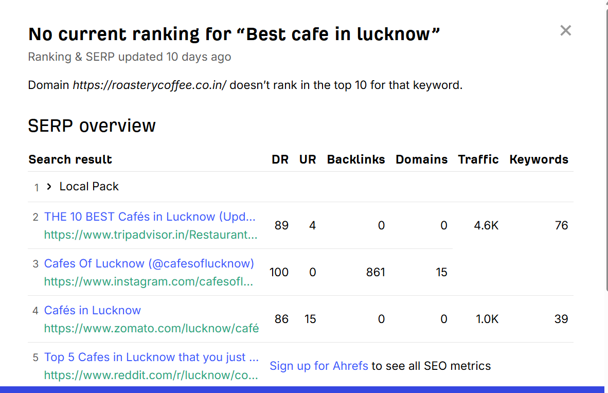
Figure 1: Roastery Coffee House not ranking for “Best café in Lucknow” (Source: Ahrefs)

Keyword Volume Analysis
Keyword search volume data was analyzed using Ubersuggest to understand user demand and search behavior.
The following keywords were identified as high-potential targets:

Keyword | Monthly Searches | SEO Difficulty
Best café in Lucknow | 6.6K | High
Instagrammable café Lucknow | 1.2K | Medium
Healthy café Lucknow | 800 | Low
Coffee near me Lucknow | 2.9K | High

The SERP is dominated by high authority and user-driven platforms such as:
- Tripadvisor (Rank #2, approximately 4.6K traffic)
- Instagram pages (Rank #3)
- Zomato (Rank #4, approximately 1K traffic)
- Reddit threads

Rank | Platform Type | Example | Traffic | Insight
1 | Local Pack | Google Maps | High | Local SEO critical
2 | Aggregator | Trip Advisor | 4.6K | High authority
3 | Social-Media | Instagram | High | Visual content matters
4 | Aggregator | Zomato | 1K | Reviews impact ranking
5 | Forum | Reddit | Medium | User opinions rank

Key Insights
- Roastery Coffee House lacks visibility for non-branded keywords
- Google favours list based and aggregator content
- Visual and user generated platforms dominate rankings
- There is a strong opportunity to rank through SEO blogs and content marketing

This analysis supports the recommendation to create blog content such as:
- “Best Cafés in Lucknow”
- “Instagrammable Cafés in Lucknow”
as these formats align with currently ranking content.

Technical SEO Analysis
A recent crawl was completed and there were some errors or issues discovered rather than that the site is healthy and functioning at an optimum level. It is likely due to quarterly tech audits that are completed by the SEO and Content Management teams to identify and mitigate any errors or issues that could potentially impact the user experience.
Some of the issues are:
- Mobile responsiveness is generally good but minor layout issues on smaller screens may affect user experience and require optimization.
- Due to the nature of the entire site the main issues that are encountered are 404 errors. Usually due to redirects, changes to sub directories or removal of blog content.
- Missing alt tags and weak internal linking reduce overall SEO effectiveness

Parameter | Issue | Recommendation
Page Speed | Moderate on mobile | Compress images
Alt Tags | Missing in some images | Add descriptive alt text
Internal Linking | Limited | Add contextual links

Content Recommendations

1)URL : https://roasterycoffee.co.in/coffee-beans/

- Existing Keyword: Roastery Coffee House Lucknow
- Target Keyword: Best Cafe in Lucknow
- Most Aesthetic café in Lucknow
- Suggested Title: Best Coffee Café in Lucknow | Roastery Coffee House
- Suggested Meta Description: Experience premium artisanal coffee at Roastery Coffee House, one of the best cafés in Lucknow. Explore our menu, ambiance and specialty brews.

Analysis of the Content
The Roastery Coffee House homepage has a clean and visually engaging UI that effectively highlights the brand’s premium positioning. The use of high-quality images and aesthetic design immediately captures user attention and reflects the café’s ambiance and experience.
There are three recommendations that should be implemented to improve the homepage:

- There are no clear call-to-actions such as “Explore Menu” and Pricing Detail which guide users toward key actions. Adding these sections will improve the user experience and engage Audience
- Another recommendation of the page is that, site can include customer reviews. This creates confidence and trust among the Customers

- A blog section or featured articles should be added to highlight topics like coffee culture and brewing techniques. This will improve SEO performance, increase organic traffic and enhance domain authority.

Recommendations are considered High Priority

2) URL : https://roasterycoffee.co.in/about-us-4/

- Existing Keyword: About Roastery Coffee House
- Target Keyword: Specialty Coffee Café in Lucknow
- Suggested Title: Specialty Coffee Café in Lucknow | About Roastery Coffee House
- Suggested Meta Description: Discover the story behind Roastery Coffee House, a leading specialty coffee café in Lucknow known for its quality brews and unique experience.

Analysis of Content
The Roastery Coffee House “About Us” page provides a clear overview of the brand story, vision and focus on specialty coffee. The content helps in building brand identity by explaining the café’s concept, quality standards and overall experience offered to customers.
The page uses simple and engaging language making it easy for users to understand the brand’s values. It also supports brand storytelling which helps create an emotional connection with the audience and builds trust.
However, the page is primarily informational and lacks strong call-to-actions that guide users toward actions such as visiting the café, exploring the menu or making a reservation.
There are two recommendations that should be implemented to improve the page:
- Internal links should be added within the content to direct users to important pages such as the menu, location and contact page. This will improve user navigation and strengthen internal linking for SEO.
- The content should be expanded with more keyword-rich information related to “specialty coffee in Lucknow” and “best café experience in Lucknow.” Including images, customer testimonials and a short video can further enhance engagement and improve SEO performance.

Recommendations are considered High Priority

3) Blog / Offers Page (Recommended to Create)
- Existing Keyword: N/A
- Target Keyword: Best Cafes in Lucknow | Coffee Culture Lucknow
- Suggested Title: Best Cafes in Lucknow | Coffee Culture & Trends
- Suggested Meta Description: Explore the growing coffee culture in Lucknow and discover why Roastery Coffee House stands out among the best cafés in the city.

Analysis of the Content
Currently, Roastery Coffee House does not have a dedicated blog or offers page which limits its ability to capture organic search traffic and engage users beyond the basic website experience.
A blog page can be used to publish SEO-driven content such as coffee guides, café experiences, trending food topics and “best cafés in Lucknow” articles. This will help in targeting non-branded keywords and increasing organic traffic.
An offers section can highlight discounts, seasonal menus and special events, which can attract repeat customers and improve engagement.
There are two recommendations that should be implemented:
- A consistent content strategy should be developed with at least 2–3 blog posts per month targeting high-search keywords related to coffee, cafés and lifestyle in Lucknow. This will improve domain authority and keyword rankings.
- The page should include internal links to menu, location and reservation pages along with strong call-to-actions such as “Visit Now” or “Explore Menu.” This will improve conversions and user flow.

Recommendations are considered High Priority

Recommended Pages
The suggestions put forward in this section will focus on creating a blog and content section for Roastery Coffee House to improve SEO performance and organic traffic.

Recommendation 1:
Title: 5 Reasons Why Roastery Coffee House is the Best Café in Lucknow!
Meta Description: Discover why Roastery Coffee House is one of the best cafés in Lucknow. From premium coffee to aesthetic ambiance, explore what makes this café a must visit destination.
- What keywords should this page use? Best cafe in Lucknow, specialty coffee Lucknow, Most Aesthetic Cafe in Lucknow
- What type of content should be provided? Content should be text-based with the use of high-quality images showcasing tempting coffee and food as well as Aesthetic Ambiance
- What potential issues does this address? The article will target users searching for top cafés in Lucknow and help improve non branded keyword rankings
- What pages can this link to? This article will link to the menu page, location page and contact page to guide users towards visiting the café
- What resources can be included to make this page more search engine friendly? Include images for each section with proper alt tags and optimize for mobile viewing
- What kind of call to action could this page use? The article should encourage users to visit the café through CTAs like “Explore Menu” or “Visit Us Today” using banners or anchor text within the content

Recommendations are considered Medium Priority

Recommendation 2
Title: Most Instagrammable Cafés in Lucknow | Roastery Coffee House
Meta Description: Finding Instagram worthy cafes in Lucknow? Discover why Roastery Coffee House is a favourite Gen Z hangout with aesthetic interiors, coffee and vibes.
- What keywords should this page use? Instagrammable cafés Lucknow, aesthetic café Lucknow, Gen Z café Lucknow, best café for photos Lucknow
- What type of content should be provided? Content should be highly visual with aesthetic images, short engaging text, and social media-style captions
- What potential issues does this address? Many Gen Z users search for visually appealing cafés for social media content. This article targets that audience and improves visibility for trending search terms
- What pages can this link to? This article should link to the gallery/menu page and Instagram page, along with the location page
- H1: Most Instagrammable Café in Lucknow
- H2: Why Roastery Coffee House is a Gen Z Favourite

- Provide recommendations as to the length of the content: The article should highlight aesthetic spots, decor, and popular photo areas in list format. Keep it engaging and short (2–3 minute read) to match Gen Z attention span .
- What resources can be included to make this page more search engine friendly? Include high quality images, reels/videos, alt tags, and embed Instagram posts
- What kind of call to action could this page use? Use CTAs like “Visit & Click Your Perfect Shot”, “Tag Us on Instagram” or “Explore Our Space”

Recommendations are considered Medium Priority

Recommendation -3
Title: Healthy Food and Coffee Options in Lucknow | Roastery Coffee House
Meta Description: Looking for healthy café options in Lucknow? Discover nutritious meals, low-calorie drinks and wholesome coffee choices at Roastery Coffee House.
- What keywords should this page use? Healthy café Lucknow, low calorie coffee Lucknow, healthy food options Lucknow.
- What type of content should be provided? Text based content with supporting images of healthy meals, drinks and ingredients that also look tempting.
- What potential issues does this address? Many health conscious customers struggle to find cafés offering nutritious and balanced options. This article will position Roastery Coffee House as a suitable destination for such audiences
- What pages can this link to? This article will have 2 internal links. One linking to the menu page highlighting healthy options and another CTA linking to the contact/location page
- H1: Healthy Café Options in Lucknow
- H2: Nutritious Choices at Roastery Coffee House
- Provide recommendations as to the length of the content: This article will include a structured list of healthy food and drink options along with brief descriptions. It should be concise and informative, approximately a 3–4 minute read .
- What kind of call to action could this page use? Users will be encouraged to explore healthy menu options and visit the café through CTAs like “Explore Healthy Menu” or “Visit Us Today”

Recommendations are considered Medium Priority

Recommendation-4
Title: Best Work Friendly Cafes in Lucknow | Roastery Coffee House
Meta Description: Looking for a perfect work friendly cafe in Lucknow? Discover why Roastery Coffee House is ideal for remote work, meetings and relaxation.
- What keywords should this page use? Work friendly café Lucknow, café with WiFi Lucknow, best café to work in Lucknow.
- What type of content should be provided? Text based content with supporting images showcasing seating, ambiance and workspace setup
- What potential issues does this address? Many users search for cafes suitable for work or study but may not be aware of Roastery Coffee House offering such an environment. This article aims to target that audience and improve discoverability
- H1: Best Work-Friendly Café in Lucknow
- H2: Why Roastery Coffee House is Perfect for Work
- Provide recommendations as to the length of the content: The article should highlight features such as WiFi availability, comfortable seating and ambiance. Include structured sections and keep it around a 4–5 minute read .
- What kind of call to action could this page use? Use CTAs like “Work from Here” or “Explore Menu” placed strategically after key sections

Recommendations are considered Medium Priority

Recommendation-5
Title: 5 Must Try Coffee Drinks at Roastery Coffee House
Meta Description: Explore the top 5 must try coffee drinks at Roastery Coffee House in Lucknow. Discover unique flavours and specialty brews loved by coffee enthusiasts.
- What keywords should this page use? Best coffee in Lucknow, must try coffee drinks in lucknow
- What type of content should be provided? Content should be text based with high quality and tempting images of coffee drinks
- What potential issues does this address? This will target users searching for recommendations and improve visibility for non-branded keywords
- What pages can this link to? This article will link to the menu page and location page to encourage visits
- H1: Best Coffee Drinks at Roastery Coffee House
- H2: 1. Signature Cold Brew
- Provide recommendations as to the length of the content: There will be 5 drinks listed in a structured format. This will help the article compete for featured snippets. The content should be concise and engaging, approximately a 3–4 minute read.
- What kind of call to action could this page use? Encourage users to visit the cafe through CTAs like “Try Now” or “Visit Us Today” within the content

Recommendations are considered Medium Priority

SEO Strategy Timeline
A structured timeline is proposed to implement SEO improvements and achieve sustainable growth in organic traffic and search rankings

Phase | Timeline | Activities | Expected Outcome
Phase 1 | Month 1 | Keyword research, technical fixes, on-page optimization | Improved website health
Phase 2 | Month 2-3 | Blog content creation (2–3 posts/month), internal linking | Increase in keyword visibility
Phase 3 | Month 4-5 | Target long-tail keywords, optimize existing pages | Gradual ranking improvement
Phase 4 | Month 6 | Performance tracking & refinement | Increase in organic traffic & engagement

Key Strategy Insights:
- Initial focus is on technical optimization and keyword targeting
- Content marketing will drive long term organic growth
- Continuous monitoring is essential to improve performance

This phased approach ensures a balance between quick wins and long term SEO growth, helping improve visibility and drive more customers to the café.

Success Metrics
Increase in Rankings
The following hero keywords will be tracked:
- Best café in Lucknow
- Specialty coffee Lucknow
- Instagrammable cafés Lucknow
- Healthy café Lucknow

Increase in Traffic
The following metrics will be measured to track performance:
- Clicks
- Impressions
- Organic Visits (SEO traffic)

User Engagement
The following metrics will be measured to track performance:
- Active Users
- Bounce Rate
- Session Length

Sales (Footfall & Conversions)
The following metrics will be measured to track performance:
- Website Clicks (Menu or Location page)
- Direction Clicks (Google Maps visits)
- Conversion (Table bookings / visits)
- Engagement Rate (Social media interactions)

Summary of Priority Recommendations

Priority | Recommendation | Goal
High | Fix 404 errors and add internal links to the Menu/Contact pages. | Improve User Flow & Crawlability
High | Create the "Best Cafes in Lucknow" and "Instagrammable" blogs. | Rank for non-branded keywords
Medium | Implement specific CTAs like "Explore Menu" on the homepage. | Increase Conversions/Footfall

SEO STRATEGY SUMMARY

The SEO strategy focuses on targeting high intent keywords to improve search visibility.
Technical optimizations will enhance website performance and user experience.
Content marketing through blog posts will help attract niche audiences such as Gen Z and health-conscious customers.
By combining keyword targeting, technical improvements and content strategy, Roastery Coffee House can improve its organic rankings and increase customer engagement.

Expected Results
- Increase in organic traffic within 3–6 months.
- Improved rankings for local and niche keywords.
- Higher engagement and website visits from targeted audiences.

